Net Load Forecasting Competition
Training Week Log
Date: 6/5/2023
Uploaded first forecast data for Donalsonville at 9:30 AM PST
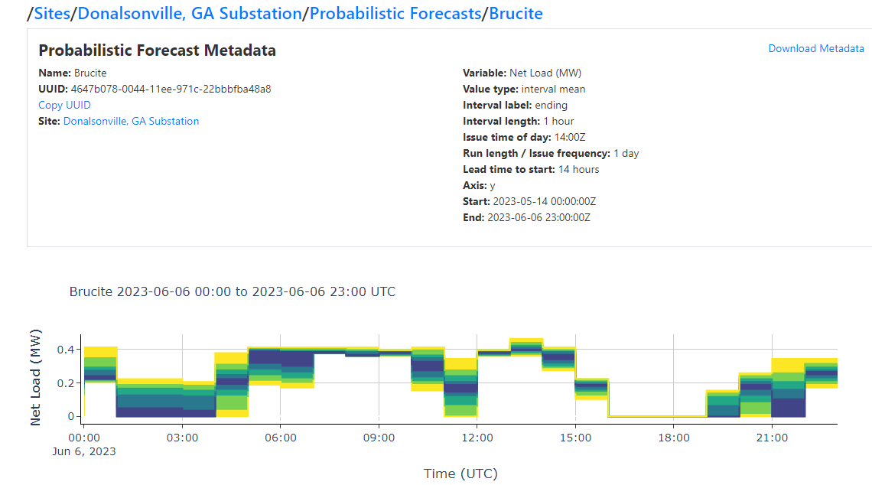
Model was UnivariateMotif with following parameters:
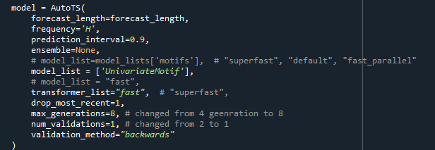
Uploaded all of the other forecasts as well just in case don’t have time to do improved ones.

6/5/2023 10:30 PM PST:
Started another prediction for 6/7 2023 UTC. Still UnivariateMotif.
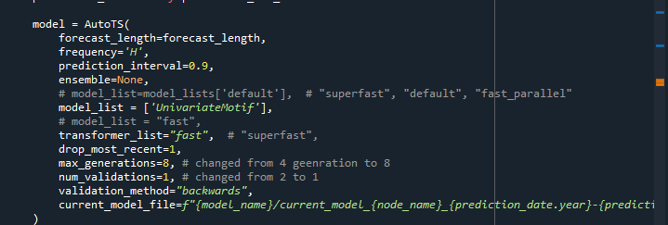
The software version had the ability to dump the parameters etc. of the model to a csv file. This was only UnivariateMotif. All models were submitted for 6/7/2023 at 6/5/2023 10:33 PM PST.
These models were renamed with their names and “_06052023b” as the end string. These were submitted at 10:30 PM PST, and moved to an archive folder. The model parameters etc. were included in these folders.
These were the model names:

Going to run the models and submissions using the following parameters for the next forecast day. This will probably take a few hours. See parameters below, going to do a more comprehensive search:
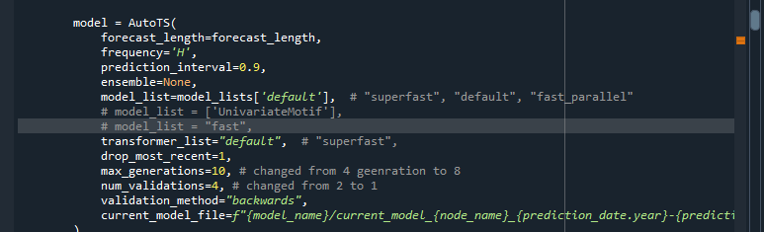
The probability spread is completely screwed up. Need to take the probabilities equally between upper forecast and lower forecast. Right now the spread for Wainane is entirely too tight. Will work on this in the morning.
6/6/2023 5:25 AM PST:
Cancelled the mode detailed search. After 7 hours it still hasn’t created one model. Maybe default, default, 10,4 is too much. It’s stuck on generation 2/10 (MultivariateRegression).
Simulated with the following parameters:
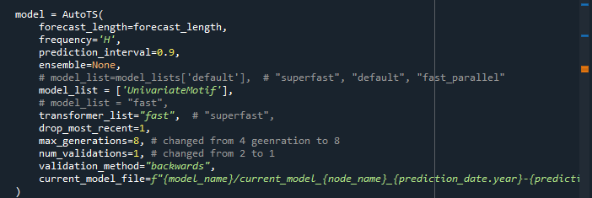
Tried to improve the probability spread but it screwed it up. Replaced upper forecast with following code:
for i in range(0, 101, 10):
if i < 50:
new_df2[f'p{i}'] = new_df[[f'p{i}_lo', f'p{i+10}_lo']].mean(axis=1)
elif i == 50:
new_df2[f'p{i}'] = = new_df[[f'p{i}_lo', f'p{i+10}_up']].mean(axis=1)
elif i > 50:
new_df2[f'p{i}'] = new_df[[f'p{i}_up', f'p{i-10}_up']].mean(axis=1)
The idea was to average the upper_forecast and lower_forecast values. Each upper_forecast gives p0, p10, etc and they put upper and lower bounds on the upper forecast. Each lower_forecast puts upper and lower bounds on the lower forecast. Wanted to average between the lower bound of the p10 upper forecast, and the lower bound of the p10 lower forecast (and so on) to get an average forecast for p10, but this code wasn’t implemented very well.
Using the upper forecast from all of the intervals in the below code will give a series where p100 lower = p0 upper. Need to look at this in more detail.
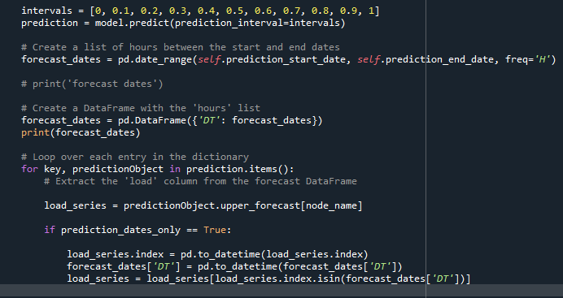
But it screwed up the prediction distribution. See screenshot:
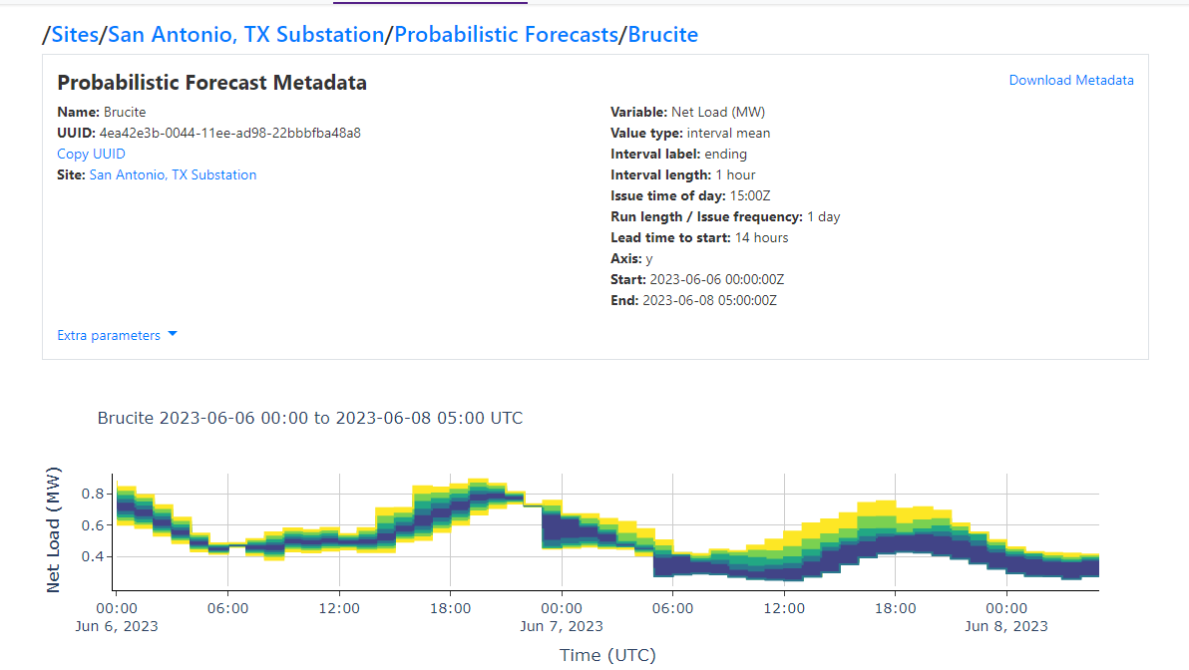
Everything after 0:00 on June 7 has the probability distribution screwed up. Couldn’t resubmit this because it was discovered too late.

Screwed up and submitted the Waianae predictions too late. Submitted before 10 AM local time, which is 1 PM PST. Maybe need to submit 1 PM the day before?
The site id and forecast id of the initial submission that was rejected were wrong. Incorrect uuids are commented out below:
# site_id = '5ebb4527-edbd-11ed-bf8d-128dcacebd72' ,
site_id = 'c639b1f3-eb8f-11ed-802e-aec5a60999dc',
# forecast_id = "56178e67-0044-11ee-bbbf-aa678857fb1c",
forecast_id = '5d2d9c84-0044-11ee-acf5-22bbbfba48a8',
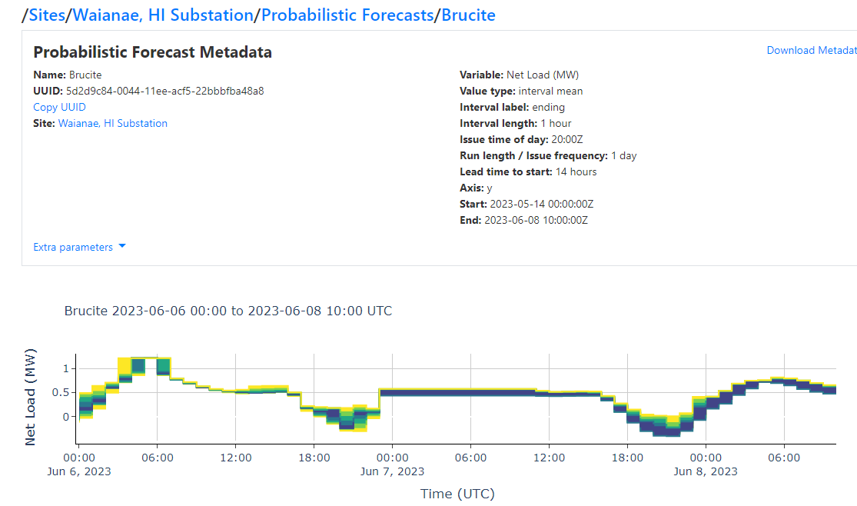
When the forecasts were submitted (around 6:30 AM 6/6/2023) the arbiter API came back with some errors wanting the forecast start date to be different values that 0:00 UTC. Need to figure out the times that are required.
Here were the time prediction ranges that were simulated. These values are in UTC.
##### AMITY SUBSTATION #####
prediction_start_date = datetime(2023, 6, 7,8)
prediction_end_date = prediction_start_date + timedelta(hours=23)
##### DONALSON SUBSTATION ####
prediction_start_date = datetime(2023, 6, 7,5)
prediction_end_date = prediction_start_date + timedelta(hours=23)
##### SAN ANTONIO SUBSTATION #####
prediction_start_date = datetime(2023, 6, 7,6)
prediction_end_date = prediction_start_date + timedelta(hours=23)
##### WAIANAE SUBSTATION #####
prediction_start_date = datetime(2023, 6, 7,11)
prediction_end_date = prediction_start_date + timedelta(hours=23)

6/9/2023
Tried to track down an error with the prediction 6/11 was making terrible guesses. Thought it had something to do with the data processing code itself changing from previous versions. This was the case: adding gas price data threw it off.
Several detailed runs were performed on test data in order to get optimal model parameters. These took a long time. This will need ot be redone with the corrected training data (the data provided on the forecast site was not correct).
AMITY BEST MODEL:
ID | Model | ModelParameters | TransformationParameters | Ensemble | Runs | smape
ca3c980e3c57e8213a28602b4ca4dfa9 | MultivariateMotif | {"window": 14, "point_method": "median", "distance_metric": "mahalanobis", "k": 10, "max_windows": null} | {"fillna": "ffill", "transformations": {"0": "RobustScaler", "1": "RobustScaler", "2": "ClipOutliers", "3": "QuantileTransformer"}, "transformation_params": {"0": {}, "1": {}, "2": {"method": "clip", "std_threshold": 4, "fillna": null}, "3": {"output_distribution": "uniform", "n_quantiles": 1000}}} | 0 | 1 | 29.11101

DONALSONVILLE BEST MODELS
Model | ModelParameters | TransformationParameters | Ensemble | Runs | smape
DatepartRegression | {"regression_model": {"model": "ExtraTrees", "model_params": {"n_estimators": 100, "min_samples_leaf": 1, "max_depth": null}}, "datepart_method": "recurring", "polynomial_degree": null, "regression_type": null} | {"fillna": "zero", "transformations": {"0": "MaxAbsScaler"}, "transformation_params": {"0": {}}} | 0 | 1 | 27.5923
e8b2c5bddc2afab6b4f8f2d4659b041d | SeasonalNaive | {"method": "lastvalue", "lag_1": 96, "lag_2": 12} | {"fillna": "zero", "transformations": {"0": "AnomalyRemoval", "1": "ClipOutliers", "2": "CenterLastValue"}, "transformation_params": {"0": {"method": "zscore", "method_params": {"distribution": "chi2", "alpha": 0.05}, "fillna": "linear", "transform_dict": {"transformations": {"0": "DatepartRegression"}, "transformation_params": {"0": {"datepart_method": "simple_3", "regression_model": {"model": "FastRidge", "model_params": {}}}}}}, "1": {"method": "clip", "std_threshold": 4, "fillna": null}, "2": {"rows": 2}}} | 0 | 1

NOTE: TheSE model didn’t complete properly, SO USED TH EMODEL from Amity.
Submitted predictions for 6/11. Suffix is _060923.
Updated data for Amity and Donalsonville because the provided data was off by an hour. Those were recomputed. Suffix is _060923c.

BEST MODELS SAN ANTONIO:
ID | Model | ModelParameters | TransformationParameters | Ensemble | Runs | smape
688c82afea7427166fa0b0fca5b4d7f0 | SectionalMotif | {"window": 10, "point_method": "midhinge", "distance_metric": "braycurtis", "include_differenced": true, "k": 10, "stride_size": 1, "regression_type": null} | {"fillna": "pchip", "transformations": {"0": "ClipOutliers", "1": "QuantileTransformer"}, "transformation_params": {"0": {"method": "clip", "std_threshold": 3, "fillna": null}, "1": {"output_distribution": "normal", "n_quantiles": 1000}}} | 0 | 5 | 21.40254

BEST MODEL WAIANAE:
ID | Model | ModelParameters | TransformationParameters | Ensemble | Runs | smape
e4c54406619853d1d1dfe6a2bfee2a87 | VAR | {"regression_type": null, "maxlags": null, "ic": "fpe"} | {"fillna": "rolling_mean_24", "transformations": {"0": "PowerTransformer", "1": "MinMaxScaler", "2": "RobustScaler", "3": "QuantileTransformer"}, "transformation_params": {"0": {}, "1": {}, "2": {}, "3": {"output_distribution": "uniform", "n_quantiles": 1000}}} | 0 | 5 | 18.5252
e083ef8434b9d78a3dffdec26fdbe1c4 | SectionalMotif | {"window": 5, "point_method": "weighted_mean", "distance_metric": "canberra", "include_differenced": true, "k": 10, "stride_size": 5, "regression_type": null} | {"fillna": "rolling_mean_24", "transformations": {"0": "QuantileTransformer", "1": "MinMaxScaler", "2": "SeasonalDifference"}, "transformation_params": {"0": {"output_distribution": "uniform", "n_quantiles": 1000}, "1": {}, "2": {"lag_1": 12, "method": "Mean"}}} | 0 | 5 | 19.44003

Note that the VAR model didn’t work, so used SectionalMotif.
Do a secondary imputation process. So when we have two sets of training data, like 1/1/2022 to 1/1/2023 then do a machine learning model for that. But we can get additional data from like 3/1/2023 to 4/13/2023. How to handle this? Use the concurrent futures approach, but instead of interpolating between the gaps, use the machine learning model created from the original training dataset to fill in the gaps to the new dataset. Then use that whole set as the training data for the machine learning model..
6/12/2023
Performed studies on optimizing ML models with AutoTS. Ran the following 4 jobs, 10 generations, 4 validations:
Amity: fast_parallel_no_arima (took 2 hrs)
Donalsonville: fast_parallel_no_arima (took 3 hrs)
San Antonio: All (took 48 hrs)
Waianae: All (took 19 hrs)
Note that the VAR model was removed from these lists as it has never worked and always thrown errors.
Results:
Amity:
Model | ModelParameters | TransformationParameters | smape
DatepartRegression | {"regression_model": {"model": "ExtraTrees", "model_params": {"n_estimators": 100, "min_samples_leaf": 1, "max_depth": null}}, "datepart_method": "recurring", "polynomial_degree": null, "regression_type": null} | {"fillna": "ffill", "transformations": {"0": "ClipOutliers", "1": "Round"}, "transformation_params": {"0": {"method": "clip", "std_threshold": 3, "fillna": null}, "1": {"model": "middle", "decimals": 0, "on_transform": false, "on_inverse": true}}} | 10.36451
DatepartRegression | {"regression_model": {"model": "ExtraTrees", "model_params": {"n_estimators": 100, "min_samples_leaf": 1, "max_depth": null}}, "datepart_method": "recurring", "polynomial_degree": null, "regression_type": null} | {"fillna": "ffill", "transformations": {"0": "ClipOutliers", "1": "Round"}, "transformation_params": {"0": {"method": "clip", "std_threshold": 3, "fillna": null}, "1": {"model": "middle", "decimals": 0, "on_transform": false, "on_inverse": true}}} | 10.36451
ETS | {"damped_trend": true, "trend": "multiplicative", "seasonal": null, "seasonal_periods": null} | {"fillna": "zero", "transformations": {"0": "ClipOutliers", "1": "Round"}, "transformation_params": {"0": {"method": "clip", "std_threshold": 3, "fillna": null}, "1": {"model": "middle", "decimals": 0, "on_transform": false, "on_inverse": true}}} | 12.96129
ETS | {"damped_trend": true, "trend": "multiplicative", "seasonal": "additive", "seasonal_periods": 24} | {"fillna": "zero", "transformations": {"0": "ClipOutliers", "1": "Round"}, "transformation_params": {"0": {"method": "clip", "std_threshold": 3, "fillna": null}, "1": {"model": "middle", "decimals": 0, "on_transform": false, "on_inverse": true}}} | 23.52419
SeasonalNaive | {"method": "mean", "lag_1": 12, "lag_2": 24} | {"fillna": "ffill", "transformations": {"0": "MaxAbsScaler", "1": "Round", "2": "MinMaxScaler"}, "transformation_params": {"0": {}, "1": {"decimals": 0, "on_transform": false, "on_inverse": true}, "2": {}}} | 17.48261
SeasonalNaive | {"method": "mean", "lag_1": 28, "lag_2": 12} | {"fillna": "zero", "transformations": {"0": "MaxAbsScaler", "1": "Round"}, "transformation_params": {"0": {}, "1": {"decimals": 0, "on_transform": false, "on_inverse": true}}} | 17.48261

Donalsonville:
Model | ModelParameters | TransformationParameters | smape
SectionalMotif | {"window": 5, "point_method": "midhinge", "distance_metric": "cosine", "include_differenced": true, "k": 5, "stride_size": 1, "regression_type": null} | {"fillna": "zero", "transformations": {"0": "QuantileTransformer", "1": "QuantileTransformer"}, "transformation_params": {"0": {"output_distribution": "uniform", "n_quantiles": 1000}, "1": {"output_distribution": "uniform", "n_quantiles": 1000}}} | 34.08049
SectionalMotif | {"window": 5, "point_method": "midhinge", "distance_metric": "cosine", "include_differenced": true, "k": 5, "stride_size": 1, "regression_type": null} | {"fillna": "zero", "transformations": {"0": "QuantileTransformer", "1": "QuantileTransformer"}, "transformation_params": {"0": {"output_distribution": "uniform", "n_quantiles": 1000}, "1": {"output_distribution": "uniform", "n_quantiles": 1000}}} | 34.08049
DatepartRegression | {"regression_model": {"model": "MLP", "model_params": {"hidden_layer_sizes": [25, 15, 25], "max_iter": 1000, "activation": "tanh", "solver": "lbfgs", "early_stopping": false, "learning_rate_init": 0.001}}, "datepart_method": "recurring", "polynomial_degree": null, "regression_type": null} | {"fillna": "zero", "transformations": {"0": "QuantileTransformer", "1": "RobustScaler", "2": "QuantileTransformer"}, "transformation_params": {"0": {"output_distribution": "uniform", "n_quantiles": 1000}, "1": {}, "2": {"output_distribution": "normal", "n_quantiles": 1000}}} | 34.90793
SectionalMotif | {"window": 5, "point_method": "midhinge", "distance_metric": "cosine", "include_differenced": true, "k": 5, "stride_size": 1, "regression_type": null} | {"fillna": "ffill", "transformations": {"0": "QuantileTransformer", "1": "QuantileTransformer", "2": "RobustScaler"}, "transformation_params": {"0": {"output_distribution": "uniform", "n_quantiles": 1000}, "1": {"output_distribution": "uniform", "n_quantiles": 1000}, "2": {}}} | 35.11865
SectionalMotif | {"window": 5, "point_method": "median", "distance_metric": "canberra", "include_differenced": true, "k": 10, "stride_size": 1, "regression_type": null} | {"fillna": "zero", "transformations": {"0": "QuantileTransformer", "1": "QuantileTransformer"}, "transformation_params": {"0": {"output_distribution": "uniform", "n_quantiles": 1000}, "1": {"output_distribution": "uniform", "n_quantiles": 1000}}} | 36.04429
SectionalMotif | {"window": 5, "point_method": "midhinge", "distance_metric": "correlation", "include_differenced": true, "k": 5, "stride_size": 2, "regression_type": null} | {"fillna": "zero", "transformations": {"0": "QuantileTransformer", "1": "RobustScaler"}, "transformation_params": {"0": {"output_distribution": "uniform", "n_quantiles": 1000}, "1": {}}} | 36.13664

San Antonio:
Model | ModelParameters | TransformationParameters | smape
UnivariateMotif | {"window": 14, "point_method": "weighted_mean", "distance_metric": "correlation", "k": 10, "max_windows": 10000} | {"fillna": "ffill", "transformations": {"0": "QuantileTransformer", "1": "SeasonalDifference", "2": "bkfilter"}, "transformation_params": {"0": {"output_distribution": "normal", "n_quantiles": 20}, "1": {"lag_1": 12, "method": "LastValue"}, "2": {}}} | 23.54664
UnivariateMotif | {"window": 14, "point_method": "weighted_mean", "distance_metric": "correlation", "k": 10, "max_windows": 10000} | {"fillna": "ffill", "transformations": {"0": "QuantileTransformer", "1": "SeasonalDifference", "2": "bkfilter"}, "transformation_params": {"0": {"output_distribution": "normal", "n_quantiles": 20}, "1": {"lag_1": 12, "method": "LastValue"}, "2": {}}} | 23.54664
DynamicFactorMQ | {"factors": 1, "factor_orders": 1, "factor_multiplicities": 2, "idiosyncratic_ar1": false} | {"fillna": "mean", "transformations": {"0": "QuantileTransformer", "1": "SeasonalDifference", "2": "StandardScaler", "3": "SinTrend"}, "transformation_params": {"0": {"output_distribution": "normal", "n_quantiles": 20}, "1": {"lag_1": 12, "method": "LastValue"}, "2": {}, "3": {}}} | 25.76589
VAR | {"regression_type": null, "maxlags": null, "ic": "aic"} | {"fillna": "time", "transformations": {"0": "QuantileTransformer", "1": "SeasonalDifference"}, "transformation_params": {"0": {"output_distribution": "normal", "n_quantiles": 20}, "1": {"lag_1": 12, "method": "LastValue"}}} | 25.40598
DynamicFactorMQ | {"factors": 1, "factor_orders": 3, "factor_multiplicities": 2, "idiosyncratic_ar1": false} | {"fillna": "mean", "transformations": {"0": "QuantileTransformer", "1": "SeasonalDifference", "2": "StandardScaler", "3": "SinTrend"}, "transformation_params": {"0": {"output_distribution": "normal", "n_quantiles": 20}, "1": {"lag_1": 12, "method": "LastValue"}, "2": {}, "3": {}}} | 25.86398
VAR | {"regression_type": null, "maxlags": null, "ic": "aic"} | {"fillna": "time", "transformations": {"0": "QuantileTransformer", "1": "SeasonalDifference", "2": "bkfilter"}, "transformation_params": {"0": {"output_distribution": "normal", "n_quantiles": 20}, "1": {"lag_1": 12, "method": "LastValue"}, "2": {}}} | 25.4345

Waianae:

Model | ModelParameters | TransformationParameters | smape
UnivariateMotif | {"window": 60, "point_method": "median", "distance_metric": "canberra", "k": 10, "max_windows": 10000} | {"fillna": "KNNImputer", "transformations": {"0": "QuantileTransformer", "1": "SeasonalDifference", "2": "MaxAbsScaler"}, "transformation_params": {"0": {"output_distribution": "uniform", "n_quantiles": 100}, "1": {"lag_1": 7, "method": "Mean"}, "2": {}}} | 18.83653
UnivariateMotif | {"window": 60, "point_method": "median", "distance_metric": "canberra", "k": 10, "max_windows": 10000} | {"fillna": "KNNImputer", "transformations": {"0": "QuantileTransformer", "1": "SeasonalDifference", "2": "MaxAbsScaler"}, "transformation_params": {"0": {"output_distribution": "uniform", "n_quantiles": 100}, "1": {"lag_1": 7, "method": "Mean"}, "2": {}}} | 18.83653
UnivariateMotif | {"window": 60, "point_method": "median", "distance_metric": "canberra", "k": 10, "max_windows": 10000} | {"fillna": "ffill_mean_biased", "transformations": {"0": "QuantileTransformer", "1": "SeasonalDifference", "2": "MaxAbsScaler"}, "transformation_params": {"0": {"output_distribution": "uniform", "n_quantiles": 100}, "1": {"lag_1": 7, "method": "Mean"}, "2": {}}} | 18.83653
UnivariateMotif | {"window": 60, "point_method": "median", "distance_metric": "canberra", "k": 10, "max_windows": 10000} | {"fillna": "ffill", "transformations": {"0": "QuantileTransformer", "1": "SeasonalDifference"}, "transformation_params": {"0": {"output_distribution": "uniform", "n_quantiles": 100}, "1": {"lag_1": 7, "method": "Mean"}}} | 18.83653
UnivariateMotif | {"window": 60, "point_method": "median", "distance_metric": "canberra", "k": 10, "max_windows": 10000} | {"fillna": "pchip", "transformations": {"0": "QuantileTransformer", "1": "KalmanSmoothing", "2": "RobustScaler"}, "transformation_params": {"0": {"output_distribution": "uniform", "n_quantiles": 100}, "1": {"model_name": "local linear stochastic seasonal dummy", "state_transition": [[1, 0, 0, 0], [0, -1, -1, -1], [0, 1, 0, 0], [0, 0, 1, 0]], "process_noise": [[1, 0, 0, 0], [0, 1, 0, 0], [0, 0, 0, 0], [0, 0, 0, 0]], "observation_model": [[1, 1, 0, 0]], "observation_noise": 0.25, "em_iter": null}, "2": {}}} | 19.20745
UnivariateMotif | {"window": 60, "point_method": "median", "distance_metric": "canberra", "k": 10, "max_windows": 10000} | {"fillna": "time", "transformations": {"0": "QuantileTransformer", "1": "KalmanSmoothing", "2": "RobustScaler"}, "transformation_params": {"0": {"output_distribution": "uniform", "n_quantiles": 100}, "1": {"model_name": "local linear stochastic seasonal dummy", "state_transition": [[1, 0, 0, 0], [0, -1, -1, -1], [0, 1, 0, 0], [0, 0, 1, 0]], "process_noise": [[1, 0, 0, 0], [0, 1, 0, 0], [0, 0, 0, 0], [0, 0, 0, 0]], "observation_model": [[1, 1, 0, 0]], "observation_noise": 0.25, "em_iter": null}, "2": {}}} | 19.20745

Interesting that Amity had the lowest MAPE seen: 10% with the DatePartRegression.
6/12/2023
Need to submit by 10 AM. The first timestamp would be 1 AM. So submit 1AM – 2AM, all the way through 12 AM.
On Monday you submit a forecast that applies to Tuesday. So
They are hour ending time averages.
First timezone forecast will be 1 AM local time.
Need to submit by 10 AM local time.
NEED OT SUBMIT JUNE 18
NEED TO SUBMIT FIRST FORECASTS ON JUNE 18 for JUNE 19
HAWAII:
Need to submit 10 AM June 18 Hawaii = 1 PM June 18 PST
Oregon:
Need to submit 10 AM June 18 Oregon = 10 AM June 18 PST
San Antonio TX
Need to submit 10 AM June 18 San Antonio = 8 AM June 18
Donalsonville GA
Need to submit 10 AM June 18 Donalsonville = 7 AM June 18 PST
Utility will probably upload only 3 times a week. Data could be like 48 hours old.
6/14/2023
Updated code – major update. Able to include weather data from areas non local to the substation. Submitted predictions with suffix 06142023.
6/15/2023
Validated data for Waianae and Donalsonville using new data they posted. Results:
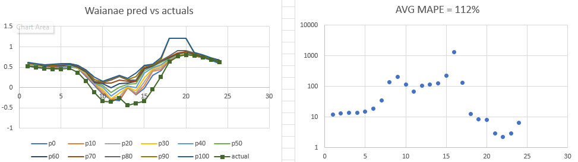
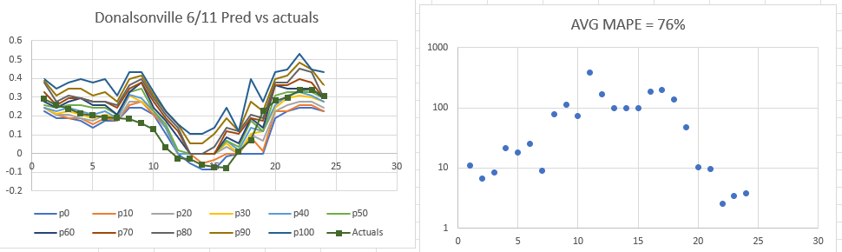
The prediction was very bad during the day, but almost at 1% 24 hours in advance.
This was for 6/12, so the day variable in the code needs to be 6/11.
Going to try and use the formula for human heat comfort in the Spatial net load forecasting textbook to see if it is improved.
Also possible that we are overfitting.
Maybe the training dataset is too long. The autots study said that good predictions can be performed with as little as 90 days of data.
The differences between this model and the ausgrid model need to be thought of further. Ausgrid predictions were way better.
Maybe try reducing training dataset length?
6/18/23
Begun submittals for competition.
6/19/23
Missed submittals for Jun 19 Amity, Donalsonville, San Antonio, Waianae because they were done manually.
Began writing script that calculates predictions and submits them automatically once every hour.
6/20/2023
Becan writing class that takes weather forecast data from NOAA and began writing regressor class which will use this data to help improve predictions.
6/23/2023
Completed class that takes forecast data from NOAA. Added regressor class and tried to use it in autots. But it didn’t work, not sure if im using it prolerly.
Also added longer training dataset length. The shape of the predictions will change after this, hopefully for the better.
Started analysis of optimal model for Donalsonville and Waianae with new training data. OInly started these two because I had questions about their accuracy, and because of limits to computational power on my machine.
6/24/23
Completed analysis of Waianae. Donalsonville crashed because of an accident with packages which wiped out my python environment. Optimal parameters:
b68fa65c9651580f2750d8b40ffc84b1 | SectionalMotif | {"window": 10, "point_method": "midhinge", "distance_metric": "canberra", "include_differenced": true, "k": 10, "stride_size": 1, "regression_type": null} | {"fillna": "mean", "transformations": {"0": "QuantileTransformer", "1": "MaxAbsScaler"}, "transformation_params": {"0": {"output_distribution": "uniform", "n_quantiles": 100}, "1": {}}} | 0 | 5 | 12.79018

This was basically the same type of model as the previous one, except with a lot better SMAPE.
6/25/23
Completed adding wet bulb temperature, total heat index, and converted wind direction to a cyclical format more suitable for machine learning. Did not add this new prediction to the submittal version.
6/26/23
Begun analysis of predictions vs actual values.
Started using optimal model for Wainae that was determined on 6/24 for the submittal data.
6/29/23
A bug was found where the wrong dates for training data were used. So everything submitted from 6/26 used old training data, not the new training data from 6/21.
Amity was using training data up until 1/1/2023.
7/1/23
Changed amity model from san Antonio 6-8 back to 6/26 wainaie model because it was too computationally intensive. See below – the yellow was the san Antonio model which was submiteted.
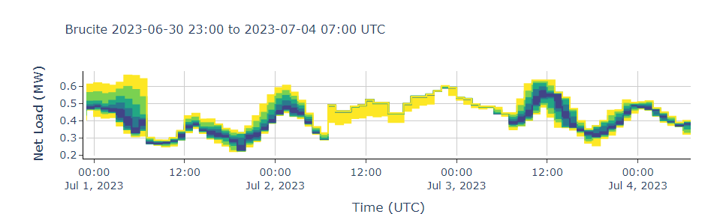
First week ranking:
- San Antonio: 47
- Waianae: 38
- Amity: 46
- Donalsonville: 39
Second week ranking:
- San Antonio: 37
- Waianae: 41
- Amity: 45
- Donalsonville: 39
7/3/2023
Completed feature using weather forecasts to predict load. Implemented this featuyre. Everything after 7/5/2023 will use the new model.
7/4/2023
Performed a study of weighting metrics for Amity.
Default metrics (regressor, 8 gen, 4 val):
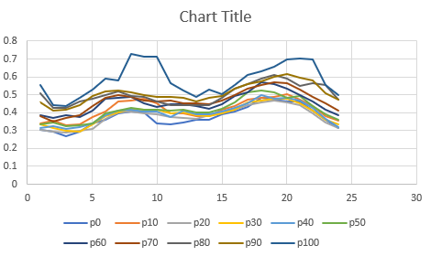
Increasing Containment weighting to 3:
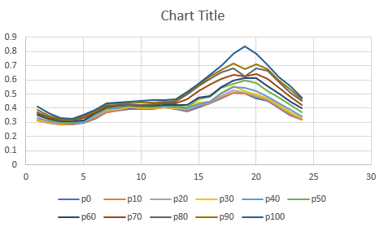
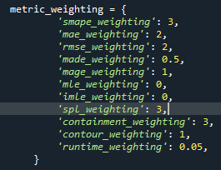
Increasing containment waiting to 5:
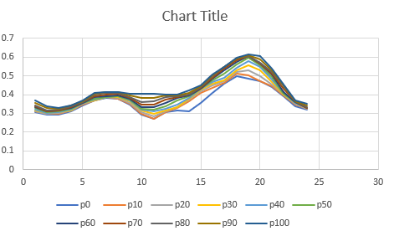
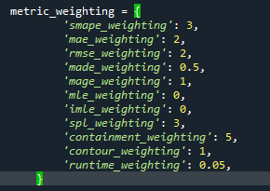
Changing to use scaled pinball loss:
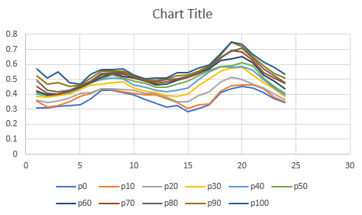
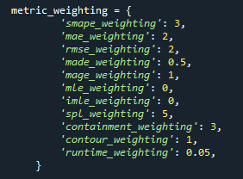
Tried again with same metrics:
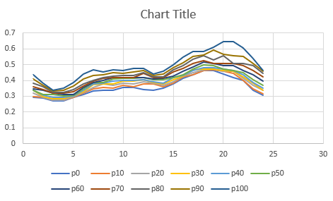
Looks different. Could be the model is not converged.
Trying again with same metrics but 12 generations, 6 validations.
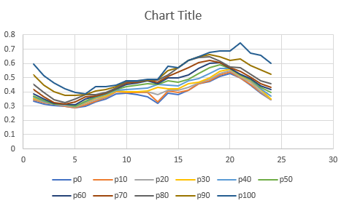

With below settings (default transformers)
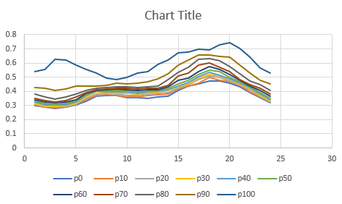
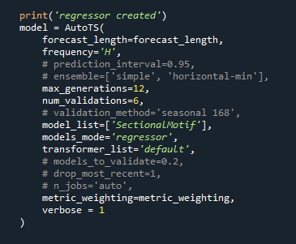
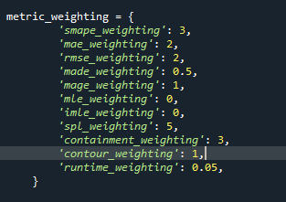

7/7/2023
First week ranking:
San Antonio: 47
Waianae: 38
Amity: 46
Donalsonville: 39
Second week ranking:
San Antonio: 37
Waianae: 41
Amity: 45
Donalsonville: 39
Current rankings:
San Antonio: 38
Waianae: 35
Amity: 38
Donalsonville: 37
